1、Head section code
<!DOCTYPE html><!-- The new doctype -->
<html lang="en"><head>
<meta http-equiv="content-type" content="text/html; charset=UTF-8">
<title>'Mono' single page layout | Script tutorials demo</title>
<meta charset="utf-8">

<!-- Linking styles -->
<link rel="stylesheet" href="css/reset.css" type="text/css" media="screen">
<link rel="stylesheet" href="css/style.css" type="text/css" media="screen">
<link rel="stylesheet" href="css/nivo-slider.css" type="text/css" media="screen">

<!-- Linking scripts -->
<script src="js/jquery.js" type="text/javascript"></script>
<script src="js/jquery.nivo.slider.pack.js" type="text/javascript"></script>
<script src="js/main.js" type="text/javascript"></script>

<!--[if lt IE 9]>
<script type="text/javascript" src="js/html5.js"></script>
<![endif]-->
</head>

2、Main layout (body)
<body>

<div class="container">
<div class="subcontainer">

<header><!-- Defining the header section of the page -->

<div class="logo"><!-- Defining the logo element -->
........
</div>

<nav><!-- Defining the navigation menu -->
........
</nav>

<section id="search"><!-- Search form -->
........
</section>

</header>

<div id="main"><!-- Defining the main content section -->

<section id="slider-wrapper"><!-- Promo slider -->
........
</section>

<section id="promo"><!-- Defining the promo section -->
.........
</section>

<section id="content"><!-- Defining the featured content section -->
........
</section>

</div>

<div id="submain"><!-- Defining submain content section -->
<section id="subcontent"><!-- Defining the content section #2 -->
<div id="left">
........
</div>
<div id="right">
........
</div>
<div class="clear"></div>
</section>
</div>

</div>

<footer><!-- Defining the footer section of the page -->
<ul id="social"><!-- Social profiles links -->
........
</ul>
<div id="privacy">
........
</div>
</footer>

</div>

</body>

- CSS
/* base styles */
body {
background:url(../images/bg.gif) repeat scroll center top #000;
color: #666666;
font-family: "Trebuchet MS",Arial,Helvetica,sans-serif;
font-size: 13px;
height: 100%;
line-height: 20px;
}
a {
color:#1799cf;
text-decoration:underline;
}
a:hover {
text-decoration:none;
}
.clear {
clear:both;
display:block;
height:0;
overflow:hidden;
visibility:hidden;
width:0;
}
.container {
margin:0 auto;
position:relative;
width:988px;

-moz-box-shadow:0 0 2px 2px #222222;
-webkit-box-shadow:0 0 2px 2px #222222;
box-shadow:0 0 2px 2px #222222;
-o-box-shadow:0 0 2px 2px #222222;
}
.subcontainer {
background-color: #FFFFFF;
padding-left: 40px;
padding-right: 40px;
}

.more {
display:inline-block;
color:#ca5d2c;
line-height:13px;
font-size:11px;
text-transform:uppercase;
border:solid 1px #edebea;
border-left-color:#ddd6d2;
border-bottom-color:#d3c9c3;
text-decoration:none;
padding:4px 9px 5px 9px;

background: -moz-linear-gradient(#ffffff, #f0edeb); /* FF 3.6+ */
background: -ms-linear-gradient(#ffffff, #f0edeb); /* IE10 */
background: -webkit-gradient(linear, left top, left bottom, color-stop(0%, #ffffff), color-stop(100%, #f0edeb)); /* Safari 4+, Chrome 2+ */
background: -webkit-linear-gradient(#ffffff, #f0edeb); /* Safari 5.1+, Chrome 10+ */
background: -o-linear-gradient(#ffffff, #f0edeb); /* Opera 11.10 */
filter: progid:DXImageTransform.Microsoft.gradient(startColorstr='#ffffff', endColorstr='#f0edeb'); /* IE6 & IE7 */
-ms-filter: "progid:DXImageTransform.Microsoft.gradient(startColorstr='#ffffff', endColorstr='#f0edeb')"; /* IE8+ */
background: linear-gradient(#ffffff, #f0edeb); /* the standard */
}
.more:hover {
color:#fff;
background:#ca5d2c;
}

四、Header section with logo and navigation

<header><!-- Defining the header section of the page -->

<div class="logo"><!-- Defining the logo element -->
<a href="#">
<img src="images/logo.png" title="Mono template" alt="Mono template" />
</a>
</div>

<nav><!-- Defining the navigation menu -->
<ul>
<li class="active"><a href="#">首页</a></li>
<li><a href="#">家具城</a></li>
<li><a href="#">建材城</a></li>
<li><a href="#">家居家饰</a></li>
</ul>
</nav>

<section id="search"><!-- Search form -->
<form action="#" onSubmit="return false;" method="get">
<input type="text" onFocus="if (this.value =='Search..' ) this.value=''" onBlur="if (this.value=='') this.value='Search..'" value="Search.." name="q">
<input type="submit" value="">
</form>
</section>

</header>



五、CSS for header section
/* header section */
header {
background: url(../images/header_inner_bg.jpg) no-repeat scroll center 0 #CC5F2D;
height: 125px;
padding-top: 21px;
position: relative;
z-index: 10;
}
.logo {
float: left;
padding-left: 49px;
position: relative;
}
.logo img {
margin:0 auto 3px;
}
#search {
overflow:hidden;
position:absolute;
right:10px;
top:10px;
}
#search form {
float:left;
background:url(../images/search1.png) no-repeat scroll 0 0 transparent;
height:28px;
width:196px;
}
#search form input[type="text"] {
background:none repeat scroll 0 0 transparent;
border:medium none;
float:left;
height:18px;
margin:0;
overflow:hidden;
padding:4px 4px 4px 11px;
width:155px;
}
#search form input[type="submit"] {
background:url(../images/search2.png) no-repeat scroll 0 0 transparent;
border:medium none;
cursor:pointer;
float:left;
height:28px;
margin:0;
overflow:hidden;
padding:0;
width:26px;
}

/*navigation menu*/
nav {
float: right;
padding-top: 75px;
}
nav ul {
padding:0px 0px 0 0;
}
nav ul > li {
float:left;
line-height:14px;
border-left:1px solid #ff9d4e;
background:url(../images/menu_bg.gif) 0 0 repeat-x #df6a35;
border-top:1px solid #ee8346;

background: -moz-linear-gradient(#eb753f, #df6a35); /* FF 3.6+ */
background: -ms-linear-gradient(#eb753f, #df6a35); /* IE10 */
background: -webkit-gradient(linear, left top, left bottom, color-stop(0%, #eb753f), color-stop(100%, #df6a35)); /* Safari 4+, Chrome 2+ */
background: -webkit-linear-gradient(#eb753f, #df6a35); /* Safari 5.1+, Chrome 10+ */
background: -o-linear-gradient(#eb753f, #df6a35); /* Opera 11.10 */
filter: progid:DXImageTransform.Microsoft.gradient(startColorstr='#eb753f', endColorstr='#df6a35'); /* IE6 & IE7 */
-ms-filter: "progid:DXImageTransform.Microsoft.gradient(startColorstr='#eb753f', endColorstr='#df6a35')"; /* IE8+ */
background: linear-gradient(#eb753f, #df6a35); /* the standard */
}
nav ul li {
position:relative;
}
nav ul > li:first-child {
border-left:solid 1px #e3773d;
}
nav ul > li:hover, nav ul > li.active, nav ul > li.sfHover {
border-top:solid 1px #a2522a;
background:url(../images/menu_bg.gif) 0 -148px repeat-x #652812;

background: -moz-linear-gradient(#9e4926, #652712); /* FF 3.6+ */
background: -ms-linear-gradient(#9e4926, #652712); /* IE10 */
background: -webkit-gradient(linear, left top, left bottom, color-stop(0%, #9e4926), color-stop(100%, #652712)); /* Safari 4+, Chrome 2+ */
background: -webkit-linear-gradient(#9e4926, #652712); /* Safari 5.1+, Chrome 10+ */
background: -o-linear-gradient(#9e4926, #652712); /* Opera 11.10 */
filter: progid:DXImageTransform.Microsoft.gradient(startColorstr='#9e4926', endColorstr='#652712'); /* IE6 & IE7 */
-ms-filter: "progid:DXImageTransform.Microsoft.gradient(startColorstr='#9e4926', endColorstr='#652712')"; /* IE8+ */
background: linear-gradient(#9e4926, #652712); /* the standard */
}
nav ul > li:hover > a, nav ul > li.active , nav ul > li.sfHover > a {
color:#f9dcb4;
}
nav ul > li > a {
display:inline-block;
color:#fff;
width:123px;
text-align:center;
line-height:18px;
font-family:"Trebuchet MS", Arial, Helvetica, sans-serif;
font-size:15px;
text-transform:uppercase;
padding:14px 0 16px;
text-decoration:none;
}

六、Main content section

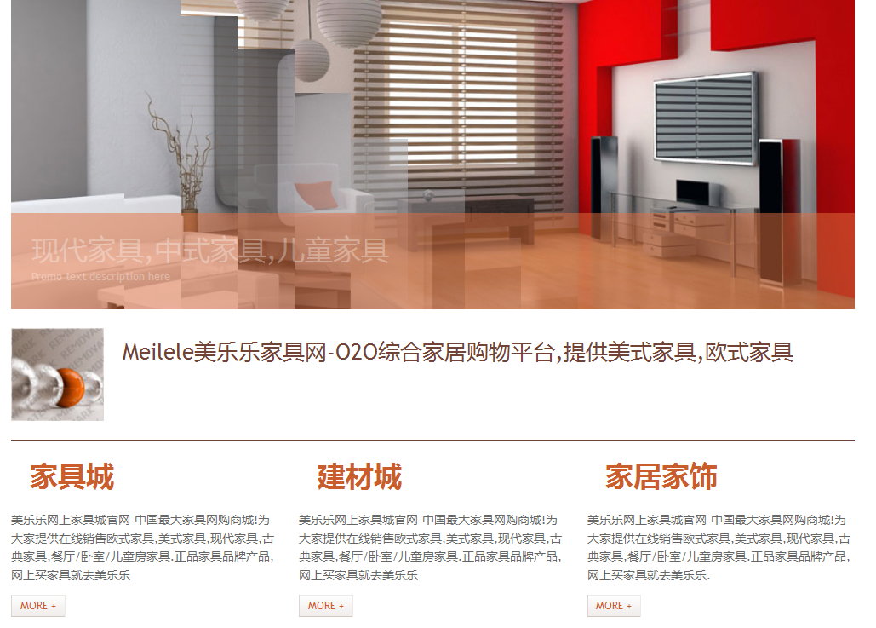
<div id="main"><!-- Defining the main content section -->

<section id="slider-wrapper"><!-- Promo slider -->
<div id="slider" class="nivoSlider">
<img style="display: none;" src="images/promo1.jpg" alt="" title="#htmlcaption-1">
<img style="display: none;" src="images/promo2.jpg" alt="" title="#htmlcaption-2">
<img style="display: none;" src="images/promo3.jpg" alt="" title="#htmlcaption-3">
</div>
<div id="htmlcaption-1" class="nivo-html-caption">
<h5 class="p2">O2O综合家居购物平台</h5>
<p>Promo text description here</p>
</div>
<div id="htmlcaption-1" class="nivo-html-caption">
<h5 class="p2">欧式家具,韩式家具</h5>
<p>Promo text description here</p>
</div>
<div id="htmlcaption-2" class="nivo-html-caption">
<h5 class="p2">现代家具,中式家具,儿童家具</h5>
<p>Promo text description here</p>
</div>
<div id="htmlcaption-3" class="nivo-html-caption">
<h5 class="p2">美国进口床垫,建材,家纺,家电等商品</h5>
<p>Promo text description here</p>
</div>
</section>

<section id="promo"><!-- Defining the promo section -->
<img alt="" src="images/promo.jpg"> Meilele美乐乐家具网-O2O综合家居购物平台,提供美式家具,欧式家具
</section>

<section id="content"><!-- Defining the featured content section -->
<ul>
<li>
<h1>家具城</h1>
<p>美乐乐网上家具城官网-中国最大家具网购商城!为大家提供在线销售欧式家具,美式家具,现代家具,古典家具,餐厅/卧室/儿童房家具.正品家具品牌产品,网上买家具就去美乐乐</p>
<a class="more" href="#">More +</a>
</li>
<li>
<h1>建材城</h1>
<p>美乐乐网上家具城官网-中国最大家具网购商城!为大家提供在线销售欧式家具,美式家具,现代家具,古典家具,餐厅/卧室/儿童房家具.正品家具品牌产品,网上买家具就去美乐乐</p>
<a class="more" href="#">More +</a>
</li>
<li>
<h1>家居家饰</h1>
<p>美乐乐网上家具城官网-中国最大家具网购商城!为大家提供在线销售欧式家具,美式家具,现代家具,古典家具,餐厅/卧室/儿童房家具.正品家具品牌产品,网上买家具就去美乐乐.</p>
<a class="more" href="#">More +</a>
</li>
</ul>
</section>

</div>

七、CSS for Main content section

/* main section */
#promo {
border-bottom: 1px solid;
color: #704336;
display: block;
font-size: 40px;
line-height: 50px;
overflow:hidden;
padding:20px 0;
position: relative;
width:908px;
}
#promo img {
float:left;
margin-right:20px;
}
#content {
border-bottom: 1px solid;
overflow:hidden;
padding:20px 0;
width:908px;
}
#content ul {
list-style:none outside none;
margin:0;
padding:0;
}
#content ul li {
float:left;
margin:0 0 0 22px;
width:288px;
}
#content ul li:first-child {
margin:0;
}
#content ul li h1 {
color: #CA5D2C;
font-size: 30px;
line-height: 1.2em;
margin: 0 0 19px;
padding-left: 20px;
}
#content ul li p {
padding-bottom: 11px;
}

八、css/nivo-slider.css

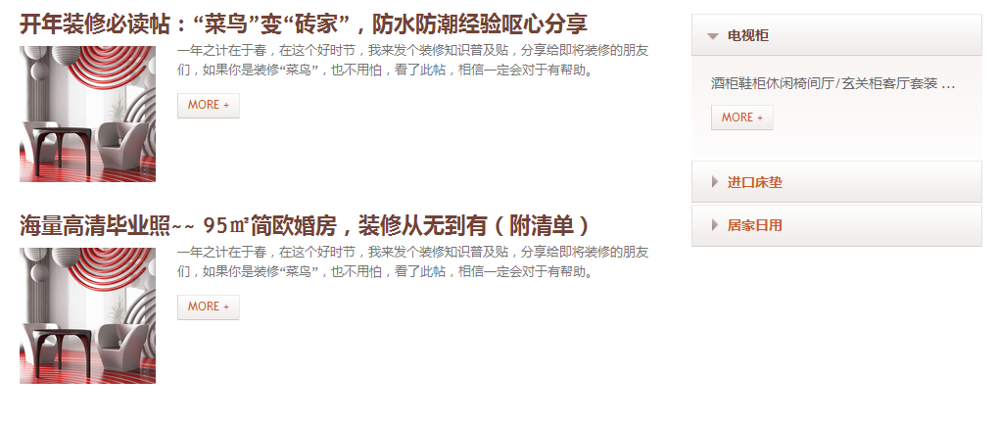
<div id="submain"><!-- Defining submain content section -->
<section id="subcontent"><!-- Defining the content section #2 -->
<div id="left">
<ul>
<li>
<h3>开年装修必读帖：“菜鸟”变“砖家”，防水防潮经验呕心分享</h3>
<img alt="" src="images/post.jpg">
<p>一年之计在于春，在这个好时节，我来发个装修知识普及贴，分享给即将装修的朋友们，如果你是装修“菜鸟”，也不用怕，看了此帖，相信一定会对于有帮助。</p>
<a class="more" href="#">More +</a>
</li>
<li>
<h3>海量高清毕业照~~ 95㎡简欧婚房，装修从无到有（附清单）</h3>
<img alt="" src="images/post.jpg">
<p>一年之计在于春，在这个好时节，我来发个装修知识普及贴，分享给即将装修的朋友们，如果你是装修“菜鸟”，也不用怕，看了此帖，相信一定会对于有帮助。</p>
<a class="more" href="#">More +</a>
</li>
</ul>
</div>
<div id="right">
<dl id="acc">
<dt class="active">
<a href="#">电视柜</a>
</dt>
<dd class="active" style="display: block;">
<p>酒柜鞋柜休闲椅间厅/玄关柜客厅套装 ...</p>
<a class="more" href="#">More +</a>
</dd>
<dt class="">
<a href="#">进口床垫</a>
</dt>
<dd style="display: none;">
<p>斗柜妆台穿衣镜床尾凳 ...</p>
<a class="more" href="#">More +</a>
</dd>
<dt>
<a href="#">居家日用</a>
</dt>
<dd>
<p>枕芯装饰摆件布艺织物厨房餐饮家居饰品 ...</p>
<a class="more" href="#">More +</a>
</dd>
</dl>
</div>
<div class="clear"></div>
</section>
</div>

</div>

CSS styles:
/* submain section */
#submain {
padding:20px 0;
}
#subcontent #left {
float:left;
width:69%;
}
#subcontent #right {
float:left;
margin-left:1%;
width:30%;
}
#subcontent ul {
list-style:none outside none;
margin:0;
padding:0;
}
#subcontent ul li {
color:#737373;
font-size:12px;
line-height:18px;
margin-bottom:10px;
overflow:hidden;
padding:7px;
}
#subcontent ul li h3 {
color: #704336;
font-size: 30px;
line-height: 1.2em;
margin-bottom: 3px;
}
#subcontent ul li img {
float:left;
height:128px;
margin:5px 20px 5px 0;
width:128px;
}
#subcontent ul li p {
padding:0 0 13px;
}

/*acc*/
dl#acc{
height:auto !important;
list-style-type:none;
padding:8px 0px 8px 0;
}
dl#acc dt{
margin-bottom:0;
margin-top:1px !important;
}
#acc dt {
background:url(../images/acc_a_bg.gif) 0 0 repeat-x #efedeb;
position:relative;
}
#acc dt.first {
padding-bottom:1px;
}
#acc dt a {
display:block;
background:url(../images/acc_marker.png) 19px -34px no-repeat;
position:relative;
padding:9px 0px 9px 33px;
overflow:hidden;
color:#ca5d2c;
font-size:13px;
font-weight:bold;
border:solid 1px #e3dedc;
border-top-color:#eeeceb;
border-bottom-color:#d7cfcb;
text-transform:uppercase;
text-decoration:none;
}
#acc dt a:hover, #acc dt.active a {
background-position:13px 18px;
color:#704336;
}
#acc dt strong {
color:#000;
float:left;
font-size:19px;
font-weight:normal;
line-height:1.2em;
padding-top:4px;
text-decoration:none;
}
#acc dd {
background:url(../images/acc_content_bg.gif) 0 0 repeat-x #fff;
display:none;
font-size:13px;
line-height:20px;
margin:0 !important;
padding:15px 20px 27px 19px;
}
#acc dd p {
padding-bottom:11px;
}

#acc dd.active {
display:block;
}

Footer section
<footer><!-- Defining the footer section of the page -->
<ul id="social"><!-- Social profiles links -->
<li><a href="#" title="facebook" rel="external nofollow"><img alt="" src="images/facebook.png"></a></li>
<li><a href="#" title="twitter" rel="external nofollow"><img alt="" src="images/twitter.png"></a></li>
<li><a href="#" title="linkedin" rel="external nofollow"><img alt="" src="images/linkedin.png"></a></li>
<li><a href="#" title="rss" rel="external nofollow"><img alt="" src="images/rss.png"></a></li>
</ul>
<div id="privacy">
© 2005-2014 美乐乐 版权所有，并保留所有权利。
</div>
</footer>

十、CSS for footer section
/* footer section */
footer {
padding:20px 40px;
text-align:right;
font-size:11px;
background-color:#f6f4f2;
overflow:hidden;
}
footer a{
text-decoration:none;
color:#5E5956;
}
#social {
float:left;
list-style:none outside none;
margin:0;
padding:0;
}
#social li {
float:left;
padding:0 0 0 3px;
}
#social li a:hover img {
margin-top:1px;
}
footer #privacy {
float:right;
}

十一、JS

js/html5.js, js/jquery.js and js/jquery.nivo.slider.pack.js
All these libraries already available in package

js/main.js
$(window).load(function() {
$('#slider').nivoSlider({
effect:'random',
slices:15,
boxCols:8,
boxRows:8,
animSpeed:500,
pauseTime:4000,
directionNav:false,
directionNavHide:false,
controlNav:false,
captionOpacity:1
});
});

$(document).ready(function() {
$("#acc dt").click(function(){
$(this).next("#acc dd")
.slideToggle("slow")
.siblings("#acc dd:visible")
.slideUp("slow");
$(this).toggleClass("active");
$(this).siblings("#acc dt").removeClass("active");
return false
})
});

